# Cryptography Homework 5

## Required reading

Crypto 5 slides

# Hand in, Part 1

Hand in screenshots of your encryption and decryption.

The student’s hand in should follow some or all of the instructions above. The file names, keys, and messages will change of course.

# Hand in, Part 2

Your foolish instructor has posted their private key, instructor_priv.pem on Canvas, along with an encrypted file. The file (also on Canvas), poem.bin was created using the procedure we just followed (Bob in the overview.) Use the private key to decrypt poem.bin. What is the title, and who was the author of the poem?

You can use the same decryption script you used before, except that you will need to read the key from instructor_priv.pem and read poem.bin instead of encrypted_data.bin.

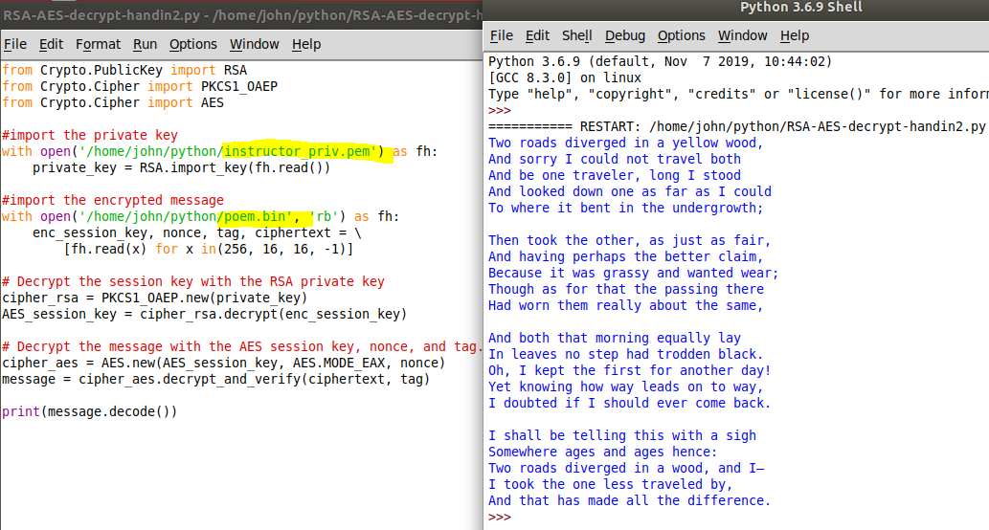

**The Road Not Taken, by Robert Frost**